Assigning IP to PC1

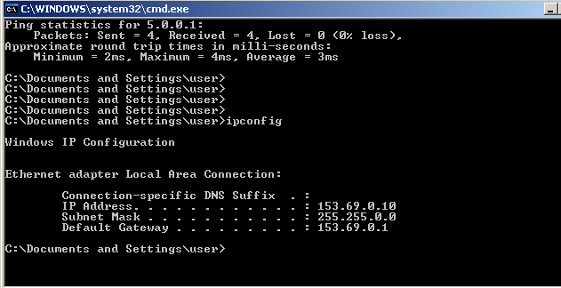

Assigning IP to PC2

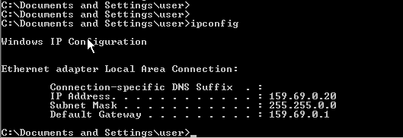

Open Linux server 1 with pc 1 via ip

Open Linux server 1 with pc 1 via name
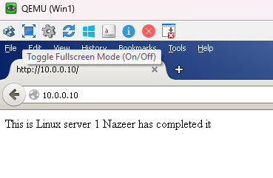
Opening Linux server 5 with pc 2 via ip

Opening Linux server 5 with pc 2 via name



Opening Window server page with pc 1 via ip



Opening Window server page with Pc 2 via name



